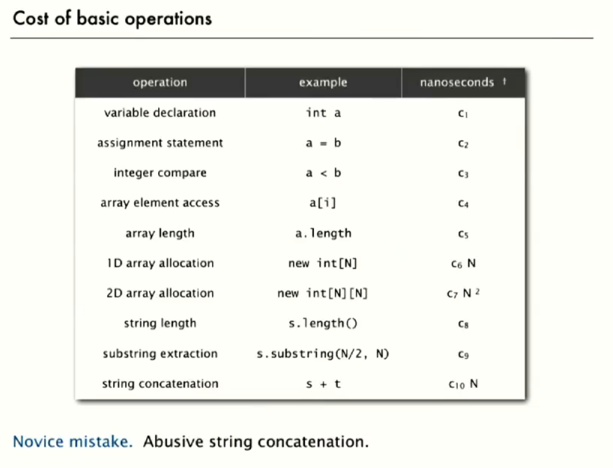

* Important: String concatenation is not a constant time operation. The running time is proportional to the length of the string.

**Tilda notation**

For Simplicity we don’t compute every single operation that algorithm does. We only compute how much the most expensive operation will take.

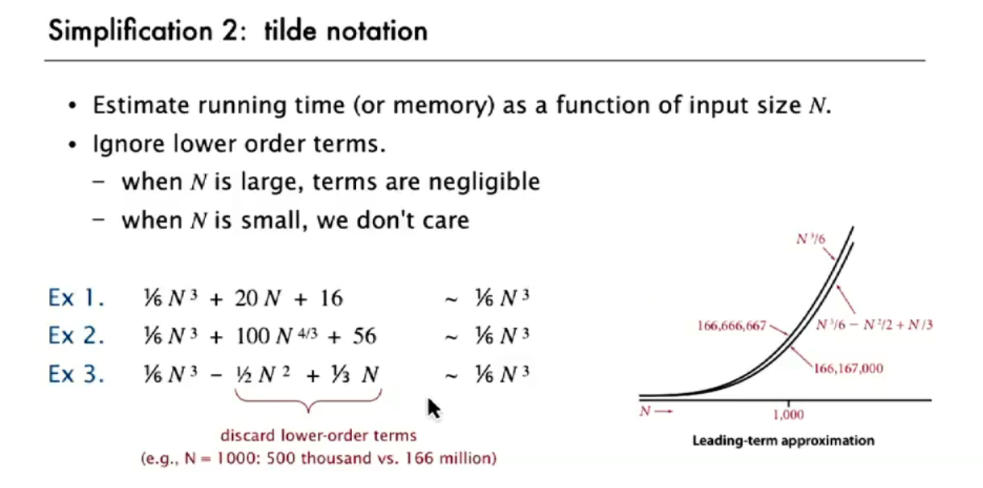

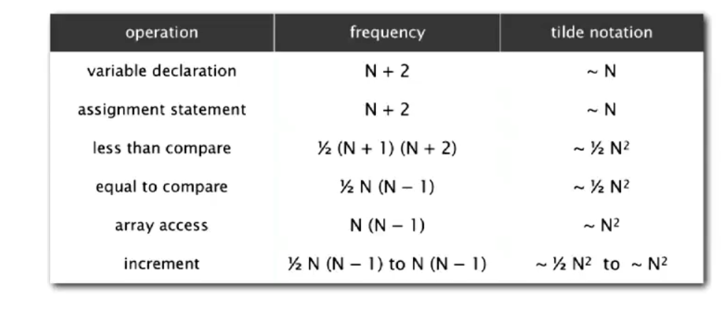

**How to compute**

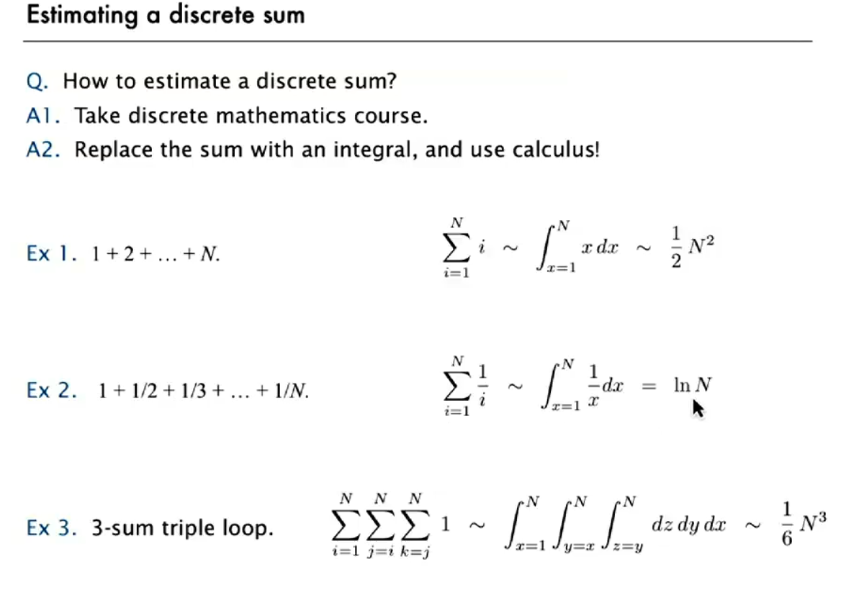

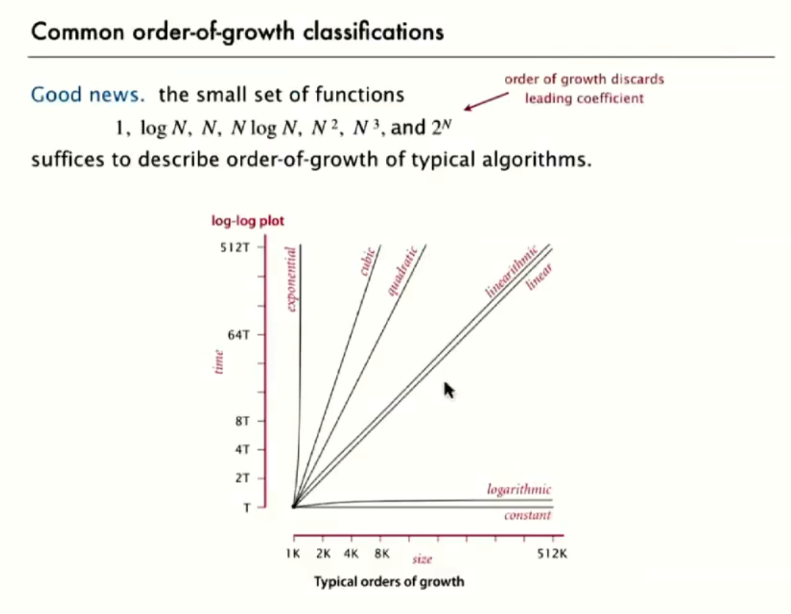

The Usual accepted algorithms are **below quadratic** ones. So those are ones which we should use for practical application.

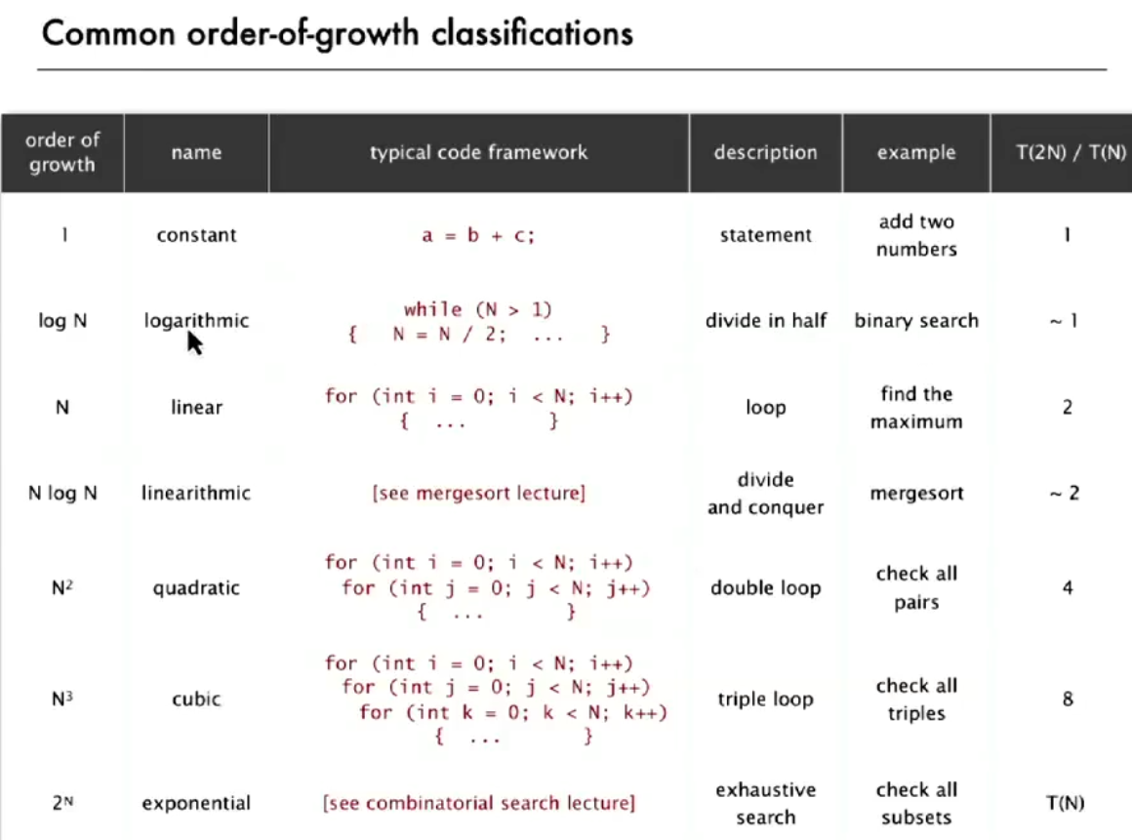

Last row shows the faction which the time increases each time we double the input. As we can see the time for quadratic and above is way high as the input grows.

